COS20019 - Cloud Computing Architecture Assignment 2
Developing a highly available Photo Album website.
Student Name: Nur E Siam
Student ID: 103842784

- Introduction
Amazon Web Services (AWS) offers a wide range of services that can be used to create a reliable and resilient photo album website. With the use of various AWS services for storage, web hosting, databases, caching, load balancing, and monitoring, we can develop an advanced and highly available photo album website with more features compared to previous assignments.
Foundation and Infrastructure
Before moving to the deployment phase, we first need to lay the foundation for our website, namely creating VPC with accurately configured subnets according to the given Architecture diagram.
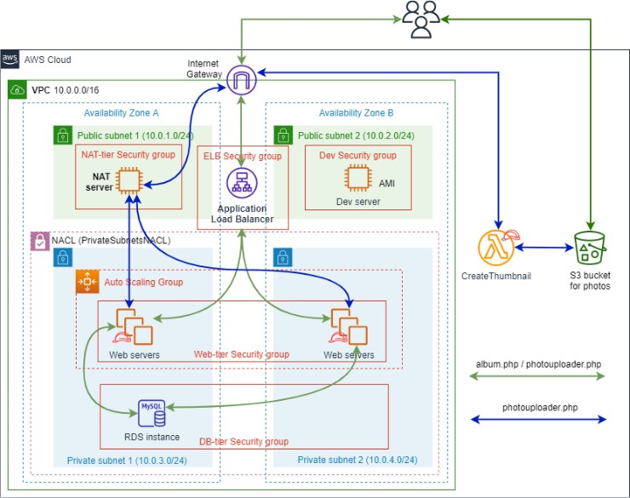
Figure 1: Architecture diagram.
This task is not so difficult as Assignment 1A and 1B has already introduced such objective. After configuring we might have a Resource map for our VPC and their according subnets as follows:

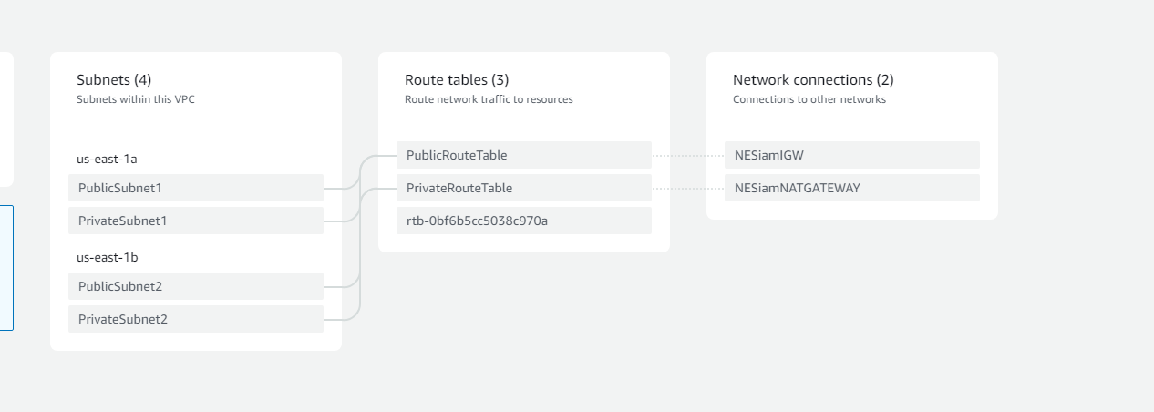
Figure 2: VPC resource map.
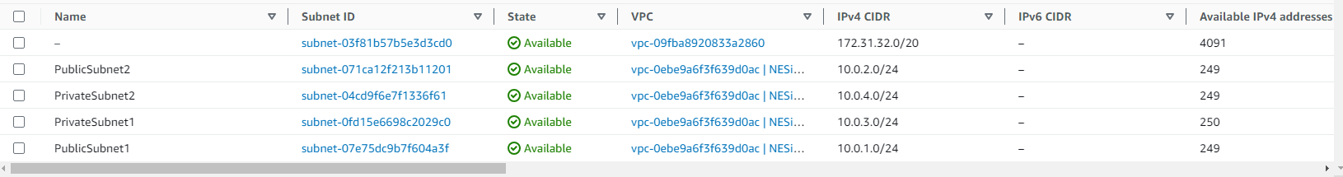
Figure 3: IPv4 CIDR for each subnet.
During the development phase, the Dev_Server_Public2 Subnet will have internet access for testing the website's functionality. Once the website is fully functional, we'll create an AMI for Dev_Server_Public2 and deploy it as needed.
The two Private subnets will host an autoscaling group and will be routed through a NAT Gateway, not a NAT instance.
The NAT Gateway will be hosted in the NAT_Server_Public1 subnet, which will be routed through the Internet Gateway. Here's a simplified diagram for reference: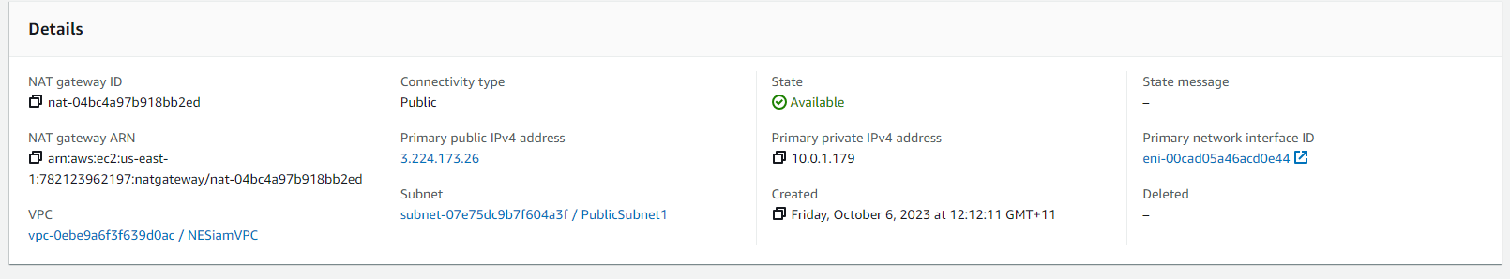
Figure 4: NAT Gateway in NAT_Server_Public1
NAT will also conclude our first stage of this assignment, with the VPC fully constructed, we will move on to create entities that reside in these subnets.

Functionalities of the Website
As mentioned above, we will develop our website in public subnet 2 and only after making sure that every functionality is satisfied will we deploy it onto other subnets. Our first task would be to make sure that S3 bucket is working.
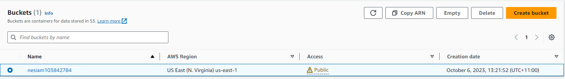
Figure 5: S3 Bucket for Assignment 2.
According to the architecture diagram our S3 bucket will only allow access from and by the Application Load Balancer (ALB), therefore, a bucket policy will be provided so as to restrict permission from and to our bucket.
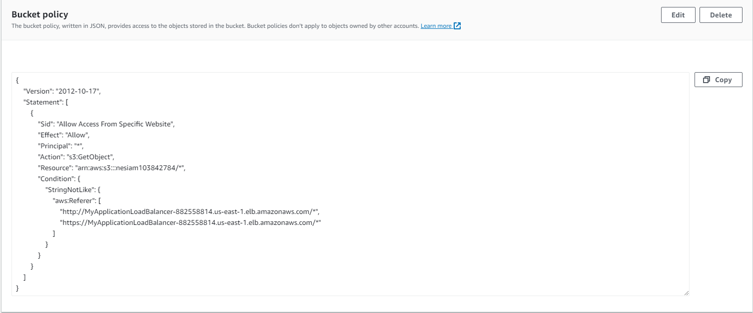
Figure 6: S3 Bucket Policy.
With the policy in its place, unauthorized access to our objects will not be possible.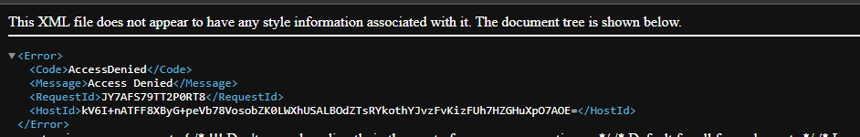
Figure 7: Unauthorized access to the S3 Objects.
A Lambda function will also be needed to resize uploaded picture to S3.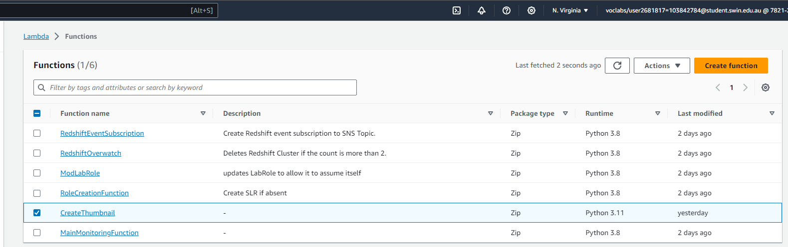
Figure 8: Lamda Function.
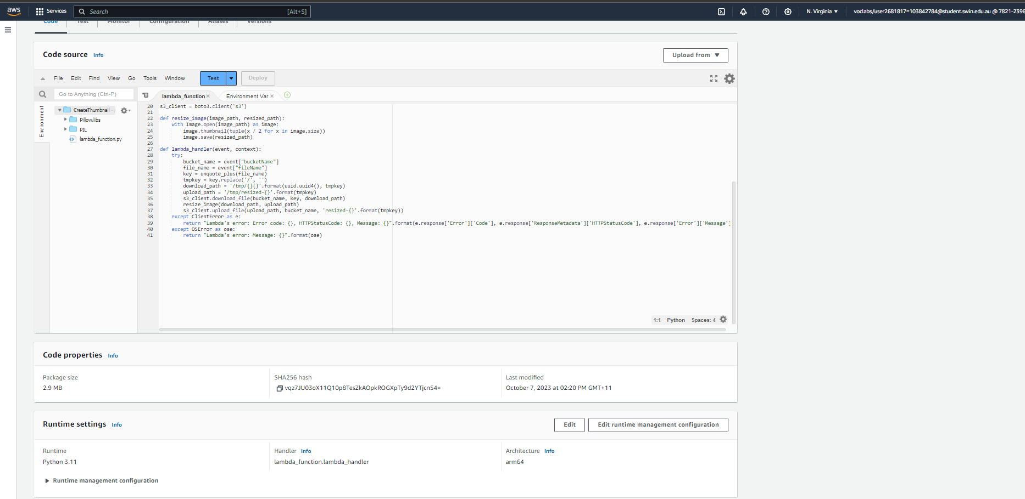
Figure 9: Code structure and properties of the Lambda function.
As the package for creating the function is provided, we only need to test the package to make sure nothing goes wrong.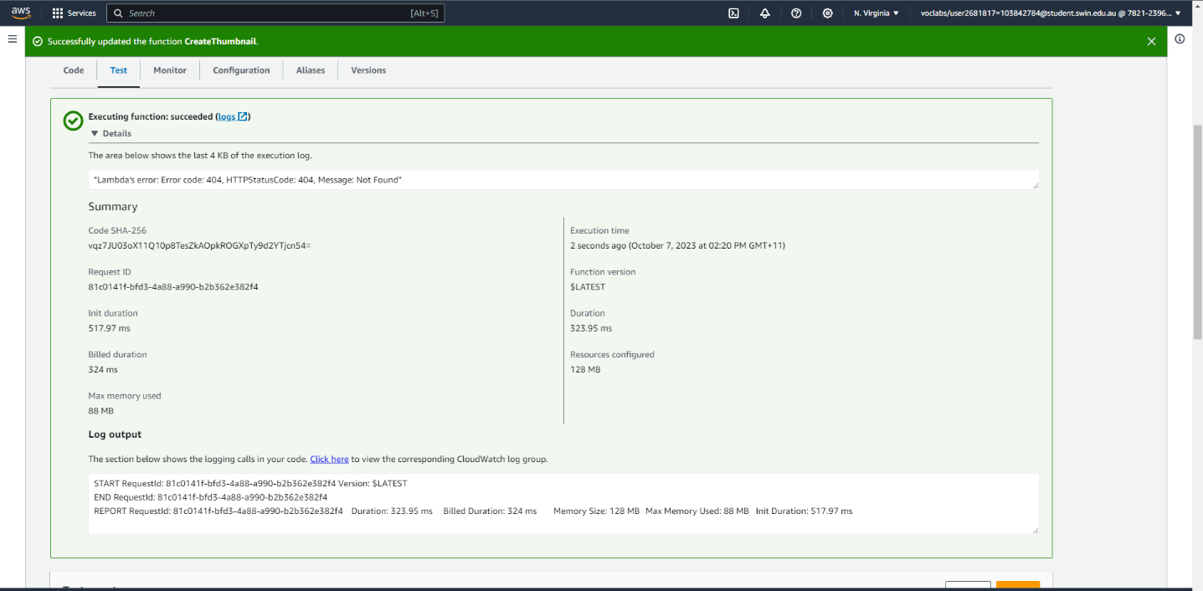
Figure 10: Lambda function test case.
With the test case successfully executed we will move onto the next part which is to create Relational Database Service (RDS), with RDS we can launch a database instance in minutes.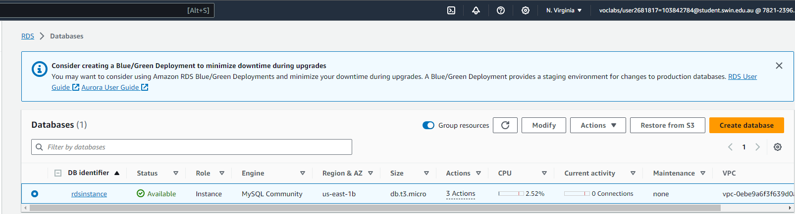
Figure 11: RDS successfully deployed.
Detailed configuration of the RDS are as follows: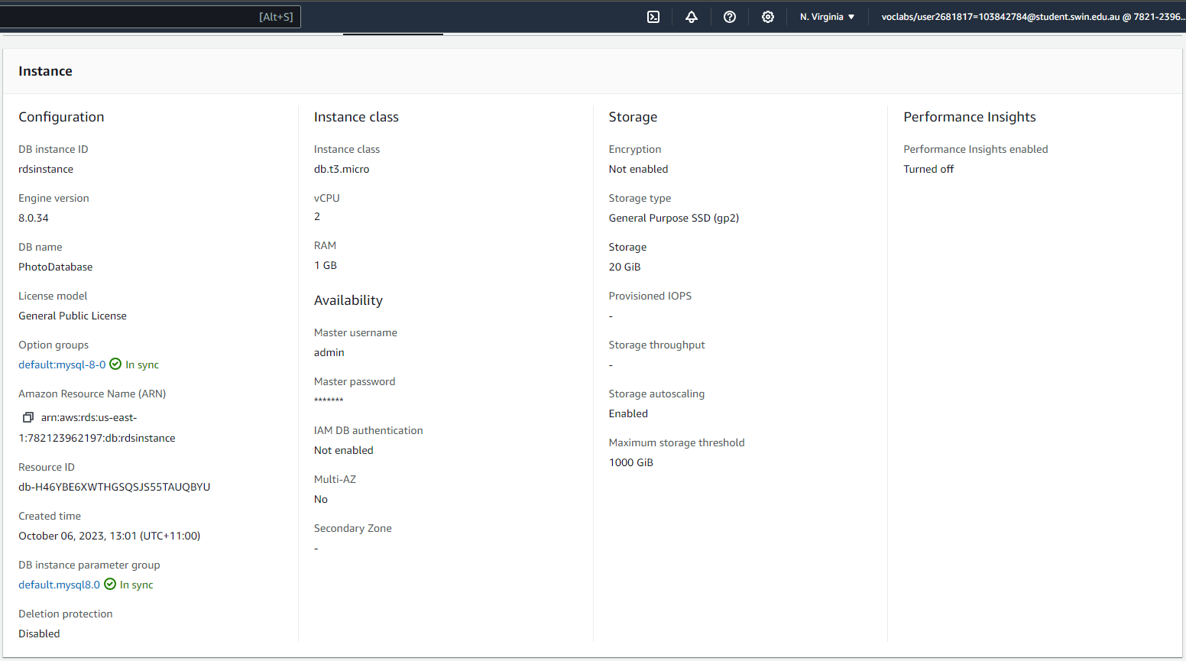
Figure 12: RDS detailed configuration.
Before we can put our website onto the development server, we will need to configure all the missing part of the provided code for the website. To be specific, we will need to modify the constant.php in the provided ZIP file.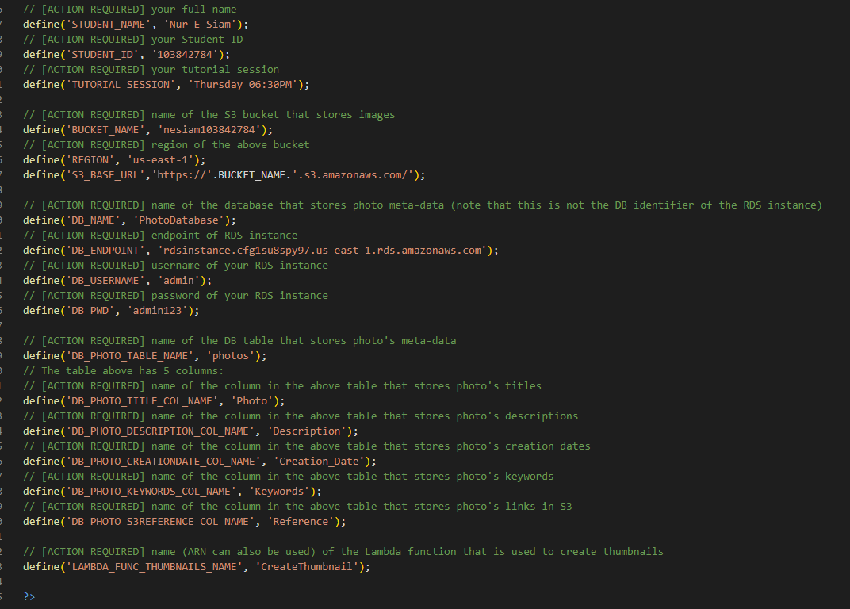
Figure 13: Modified constant.php.
With all the components successfully configured, we can then move to creating an EC2 instance on the development server.

Development of the Website using EC2 and AMI
All the functionalities of our website will require a host to work, an EC2 instance would be an ideal environment for our website. Also an IAM role would also be necessary to be able to put objects into the S3 bucket and invoke the CreateThumbnail Lambda function.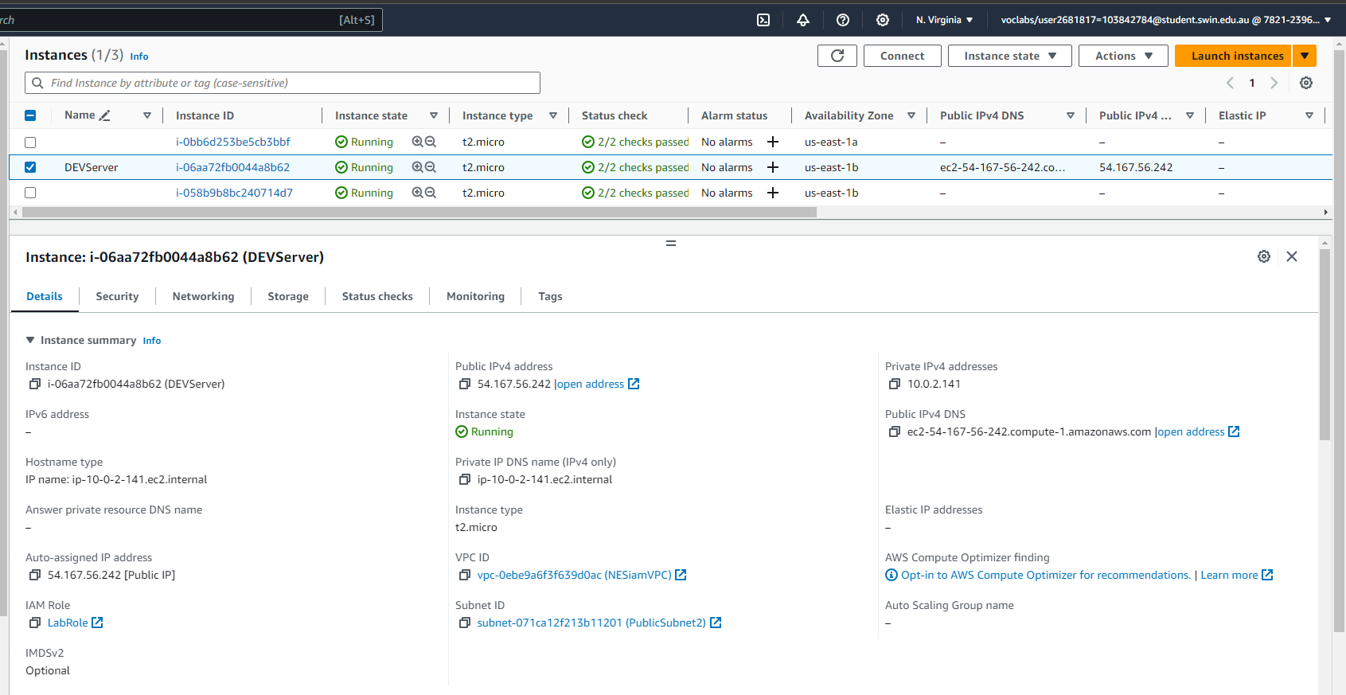
Figure 14:DevServerInstances with IAM role.
After deploying the EC2 instance, we can check if it is accessible by allocating for it an Elastic Ips and access the website via its public IPv4 DNS: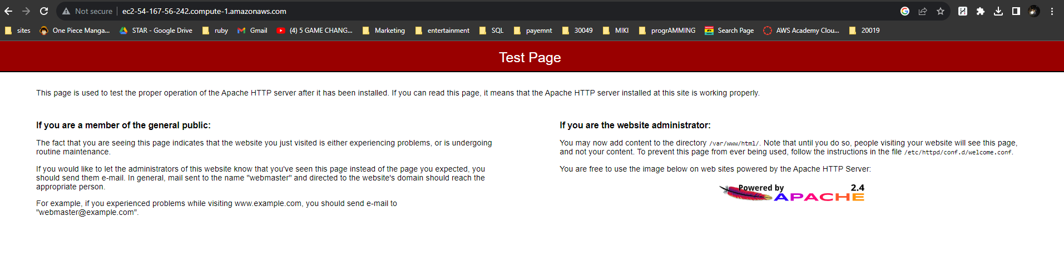
Figure 15: EC2 Instance successfully deployed.

We will then connect to the instance via SSH to configure the database using the same Public IPv4 DNS.
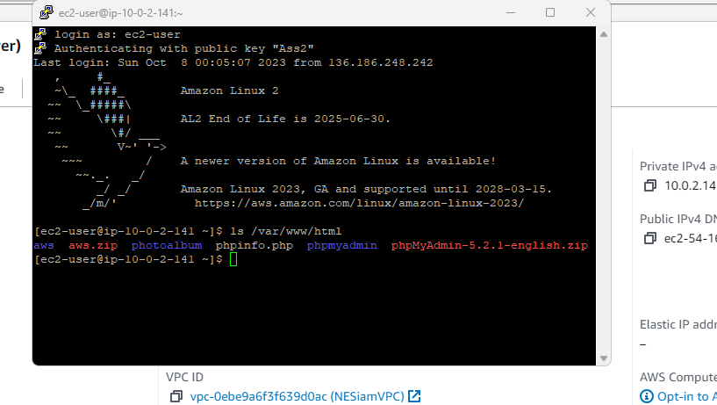
Figure 16: DevServer SSH terminal.
To set up phpMyAdmin for creating database metadata and monitoring the database's performance, you need to make a minor modification in the config.inc.php file. This change will establish a connection between your phpMyAdmin console and the RDS instance created in stage 3.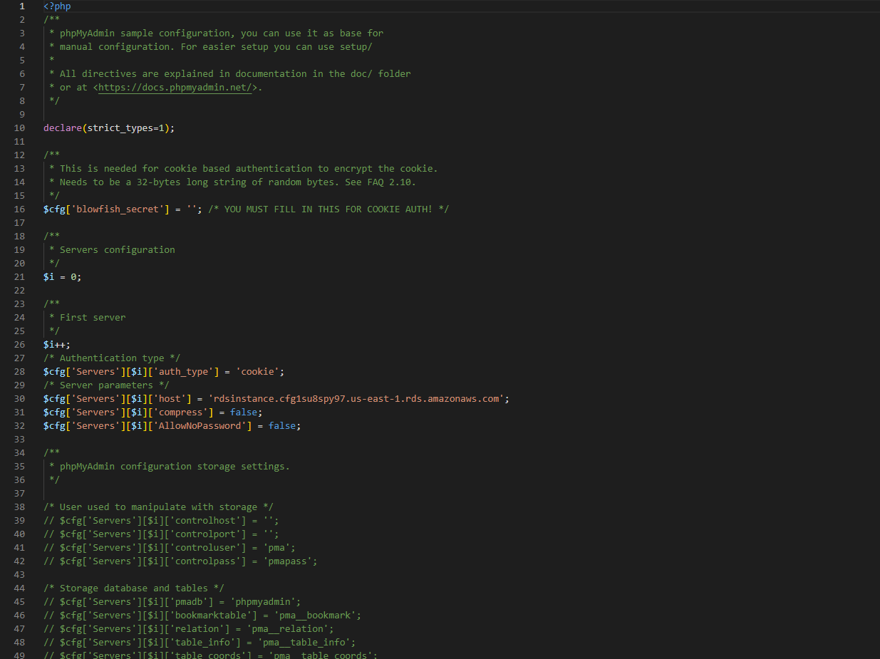
Figure 17: config.inc.php

After changing the value of ‘localhost’ in config.inc.php we can access phpMyAdmin on our developing server website to create meta-data for our database.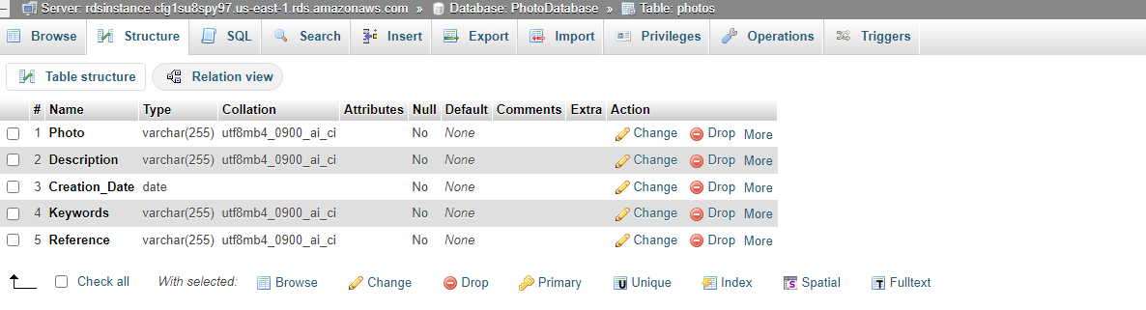
Figure 18: Meta-data for the database.
We can then upload the provided codes to test our website.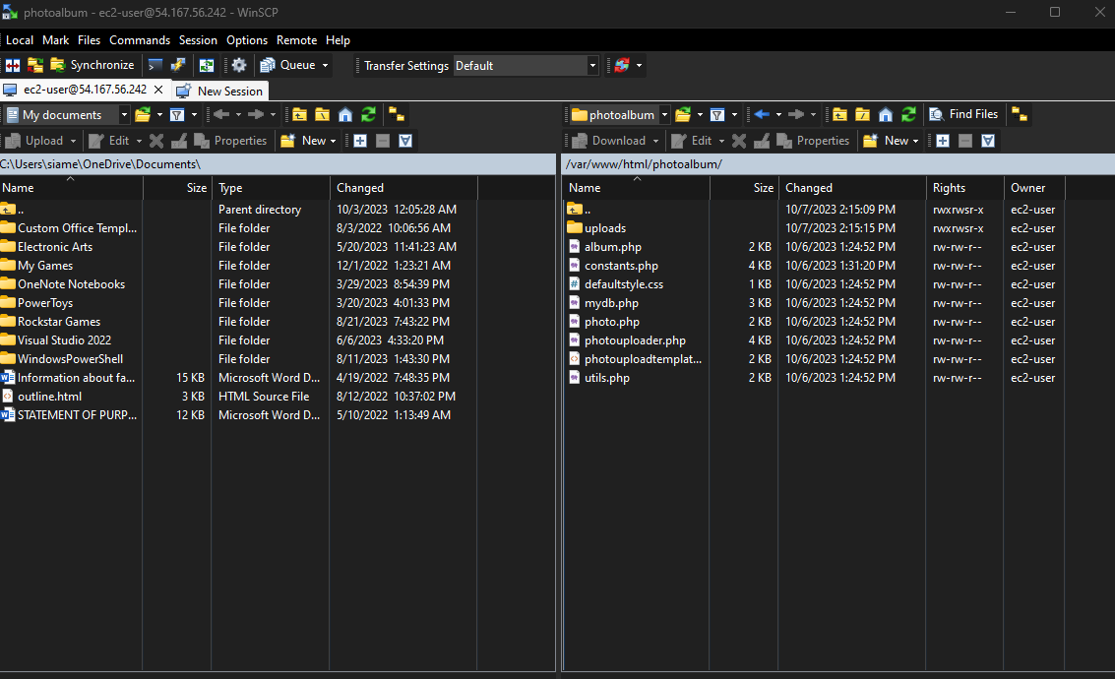
Figure 19: Uploaded codes for the website.
Our album.php site on the developing server website would look like this: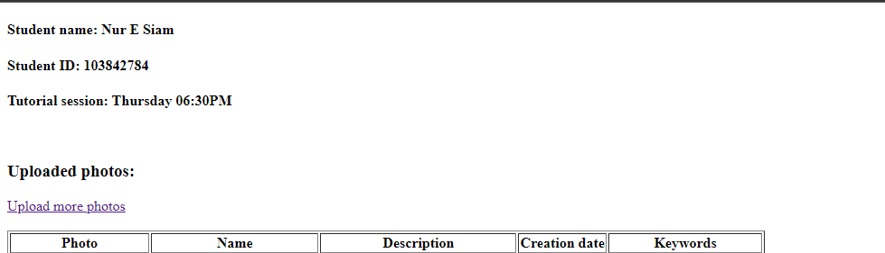
Figure 20: album.php

We can proceed to upload some photos on the website.
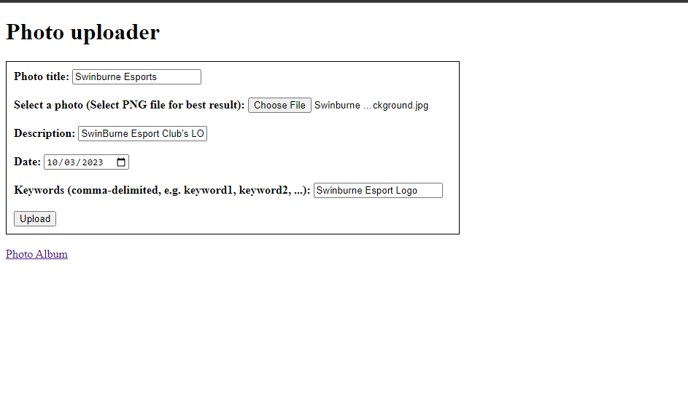
Figure 21: photouploader.php.
we can see that S3 and the meta data in phpMyAdmin works as expected.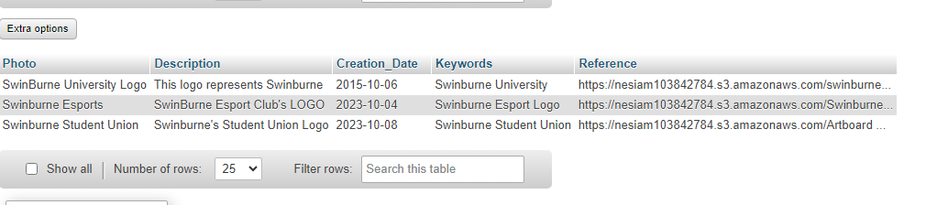
Figure 22: Meta-data in phpMyAdmin.
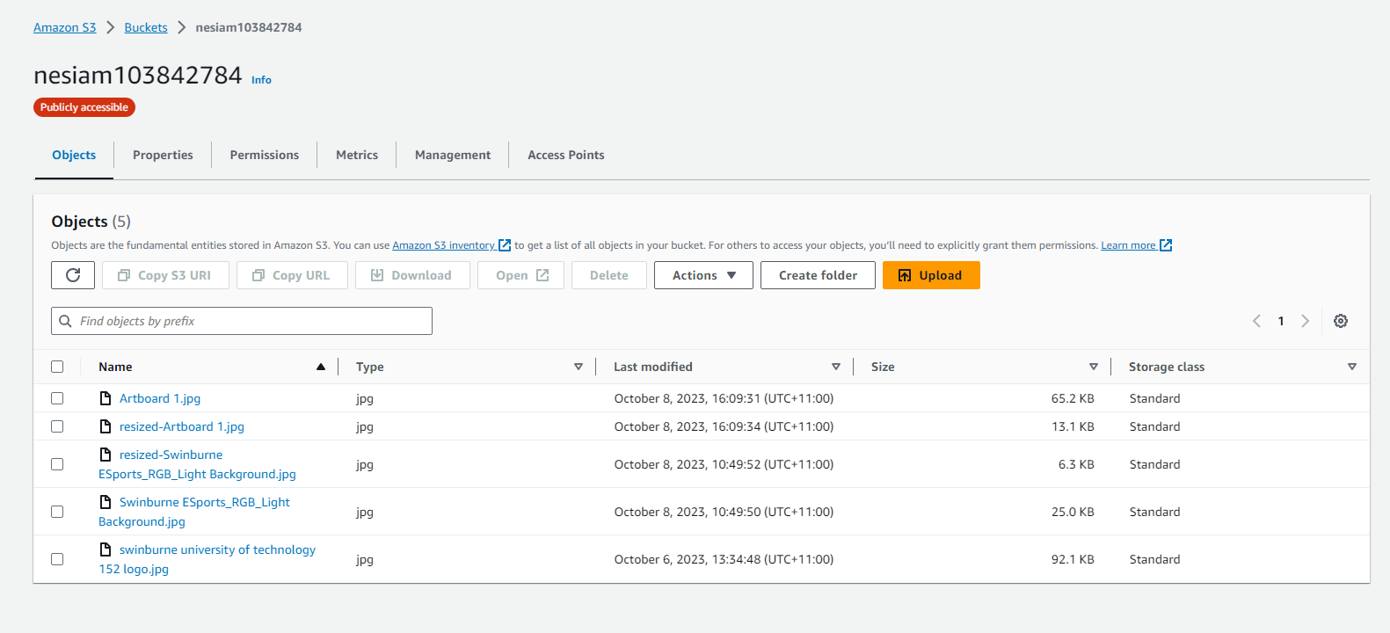
Figure 23: Resized objects in S3 Bucket.

The website's functionality has been successfully configured and tested. We are now ready to proceed with creating an Amazon Machine Image (AMI) of the DevServer and deploying it within our Auto Scaling Group.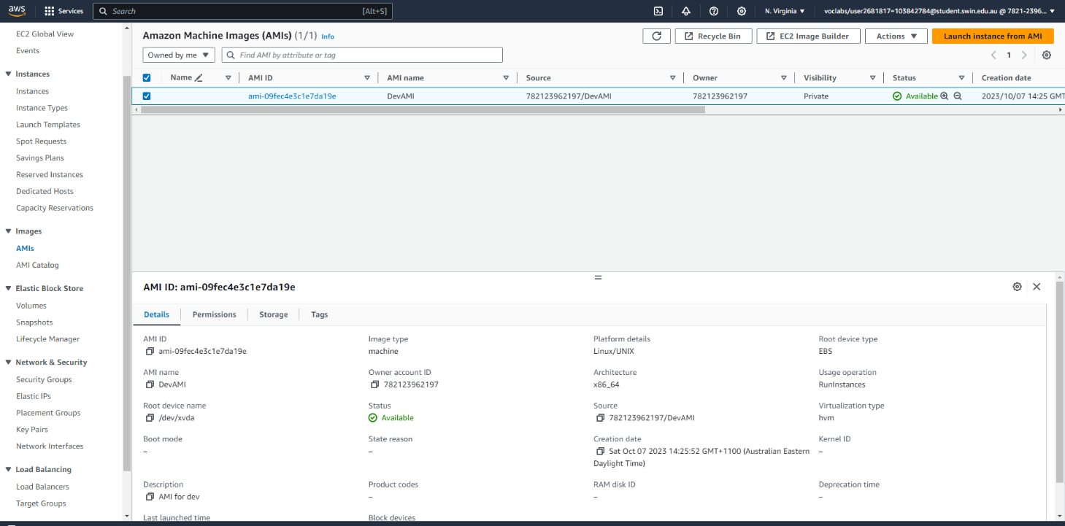
Figure 24: AMI of DevServer.

Elastic Load Balancer and Auto Scaling Group

Now that the development process is complete, our next steps involve enhancing the website's high availability and scalability by utilizing Elastic Load Balancer and Auto Scaling Group. we need to ensure that the IAM is applied correctly using the provided profile.
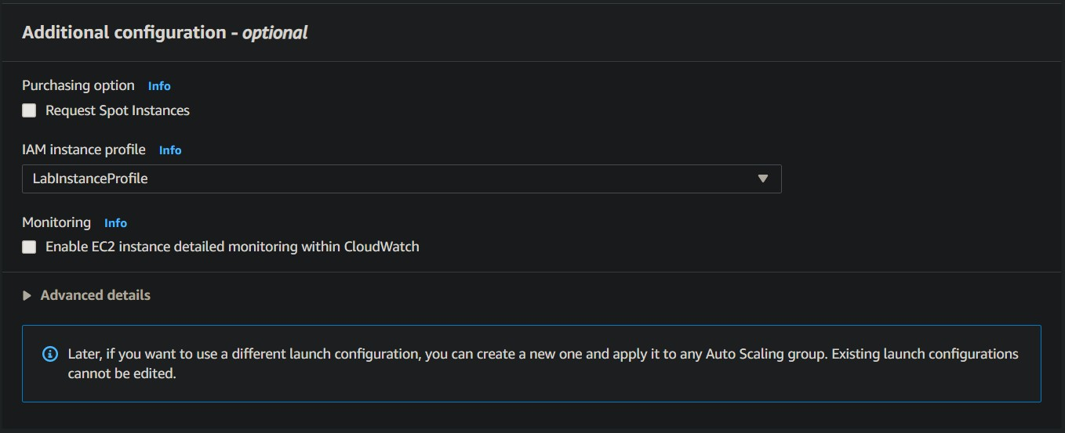
Figure 25: IAM configuration
After that we can create an Auto Scaling Group that will control the Web Server Instance.

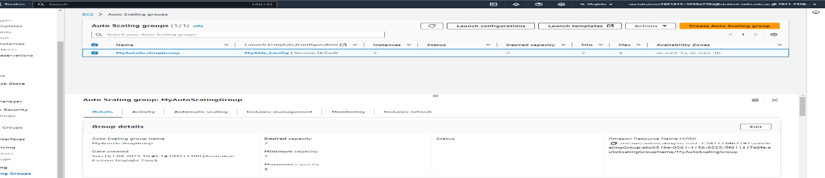
Figure 26: Auto Scaling Group.
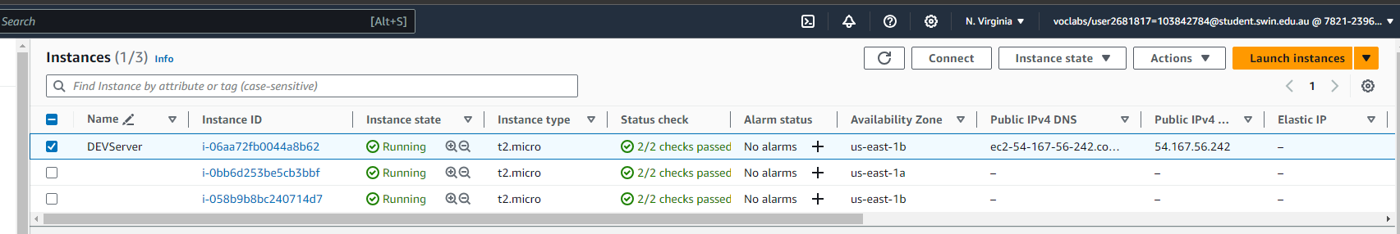
Figure 27: Two Instance creating from Auto Scaling Group.
A Target group is needed to launch the load balancer.
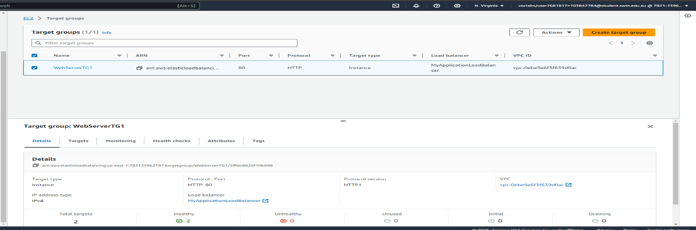
Figure 28: Target group attached to the Load Balancer.

Our Load Balancer will look like this.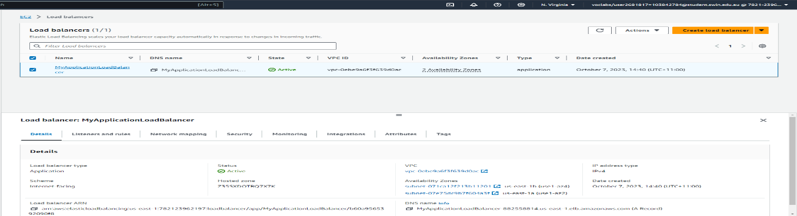
Figure 29: Load Balancer.
We can then use the DNS name provided by the Load Balancer to access our Web Server Instances created by the Auto Scaling Group.
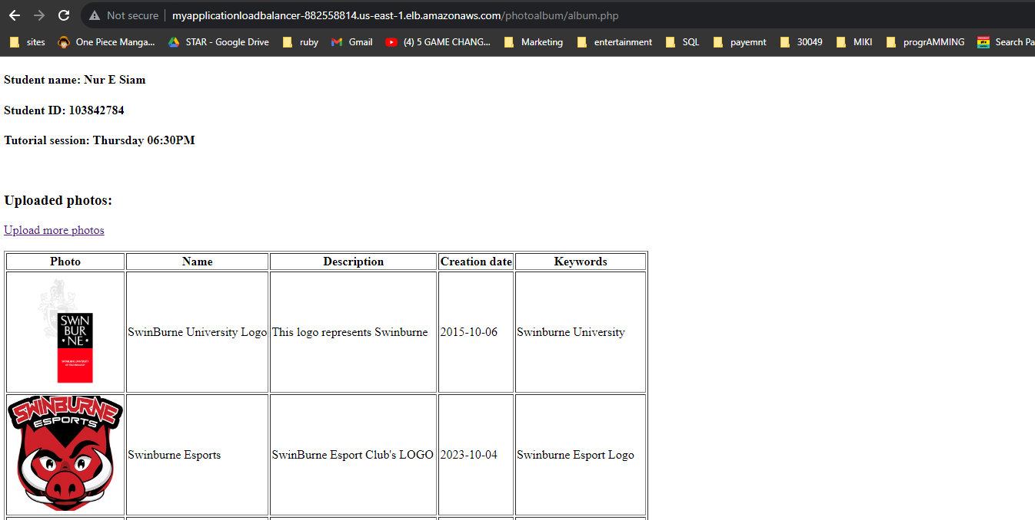
Figure 30: Album.php accessed from the Load Balancer.
As the S3 Bucket will only allow access from the Load Balancer that we just created, the picture of a logo will be presented. We can also upload more logos to test the functionality of the website.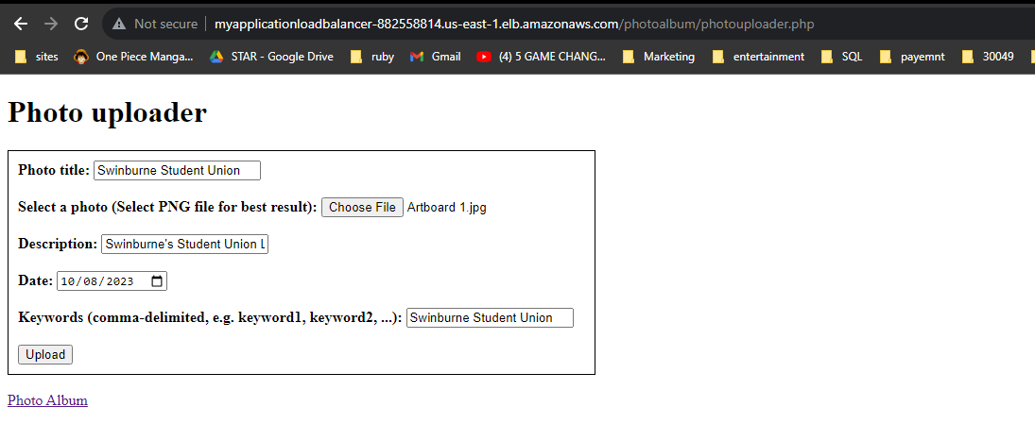
Figure 31: photouploader.php accessed from the Load Balancer.
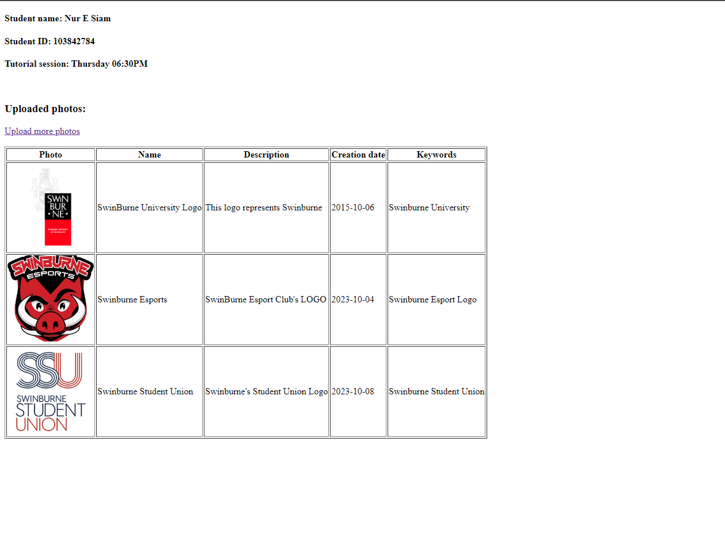
Figure 32: Functionalities test from Load Balancer.

Security Group and Network ACL
After making sure that all of our Web Server Instances are working properly, we can then proceed to ensure Security and Accessibility to and from our Web Server Instances.
Web Server Security Group should only accept Inbound from Elastic Load Balancer and Outbound to the NAT gateway.
DevServer Security Group can accept Inbound and Outbound from All Traffics.
Database Server Security Group can accept all Inbound and Outbound traffics from the Webserver and the Devserver.
The Elastic Load Balancer Security Group can accept all Inbound and Outbound Traffics from the Internet Gateway.
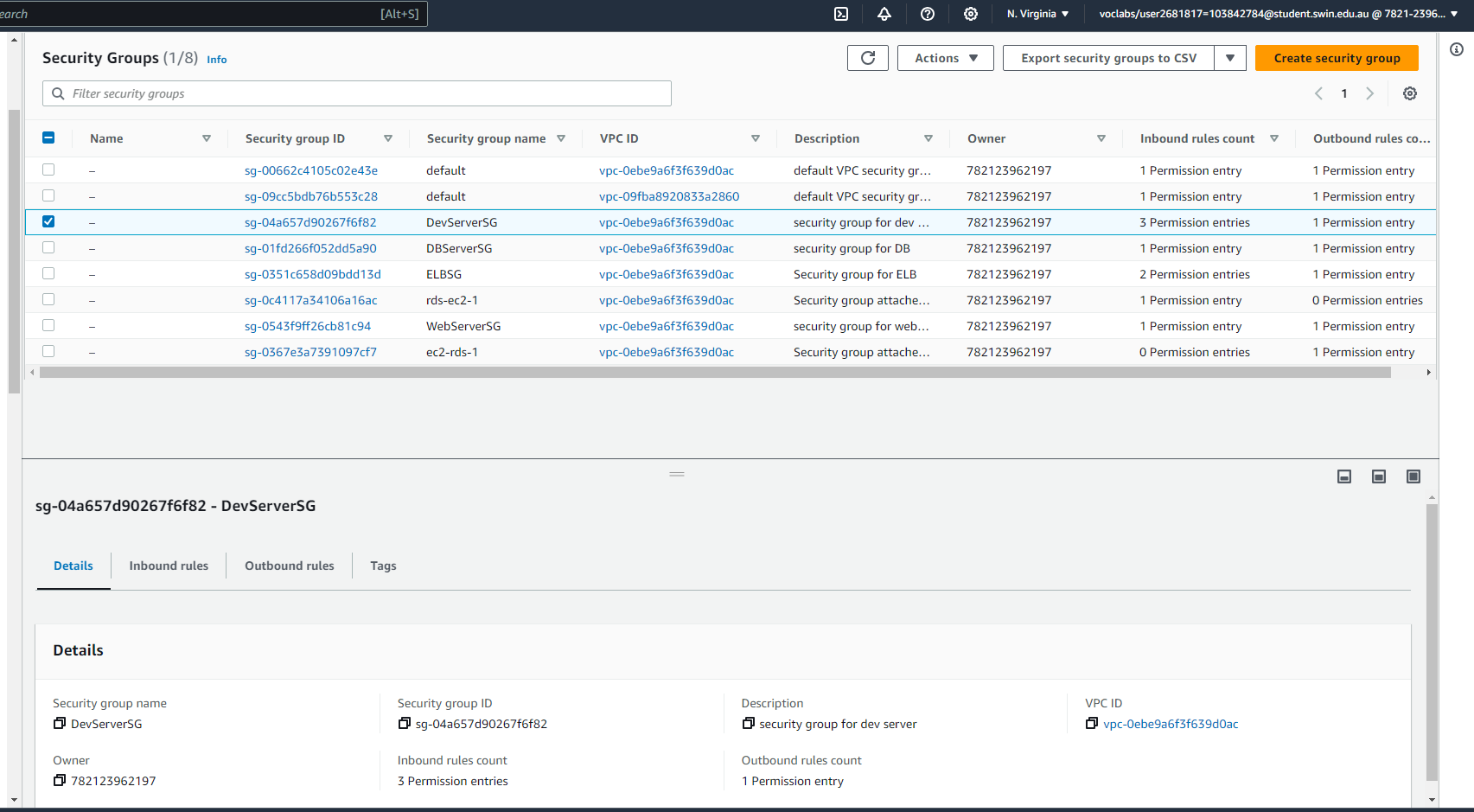
Figure 33: Security Groups
Network ACL is going to be the last part of our configuration, we will create an ACL that will restrict DevServer from sending ICMP packet to the WebServer.
The Inbound and Outbound rules for our Network ACL will look like this.
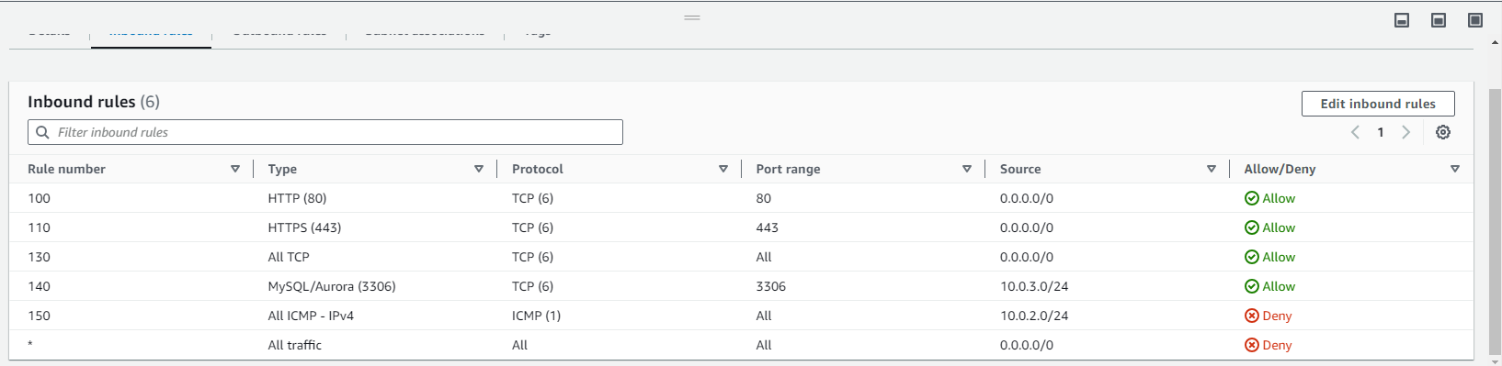
Figure 34: Network ACLs.

Testing

We will conduct several tests to verify that the website's functionality has been properly configured. While some tests have already been performed earlier, this section will cover the remaining tests.
Test 1: Ping Test
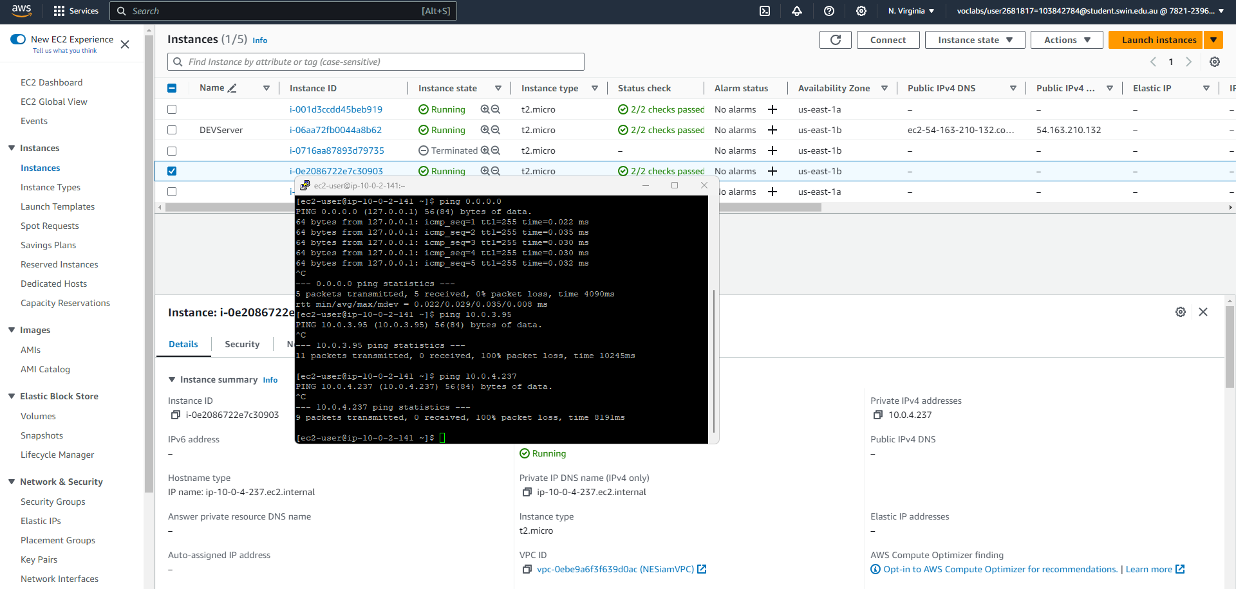
Figure 35: All ICMP Testing.
Test 2: Termination of Auto instance and Auto Scaling group
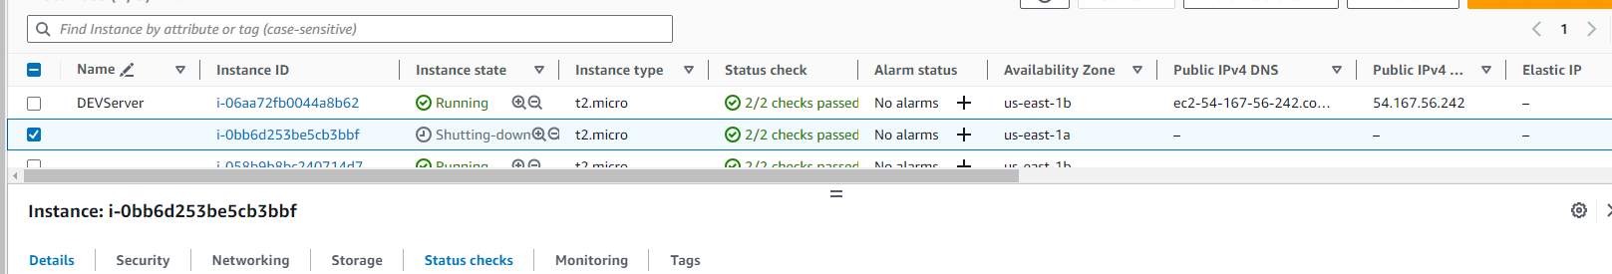
Figure 36: Termination of a webinstance from Auto scaling group.
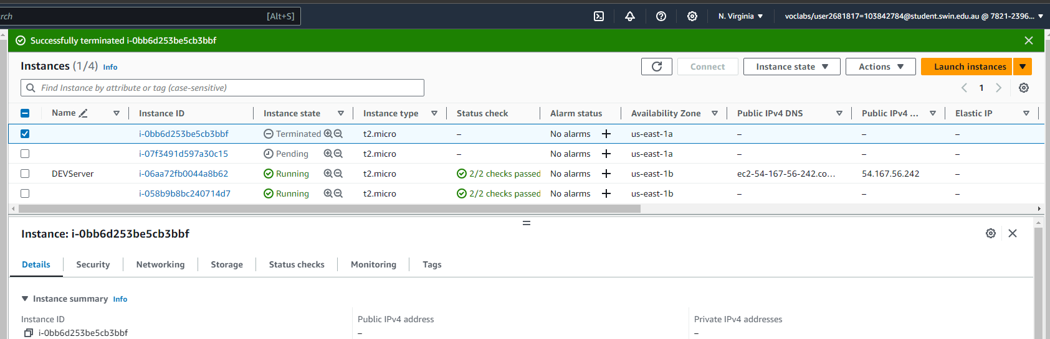
Figure 37: Creating a webinstance.
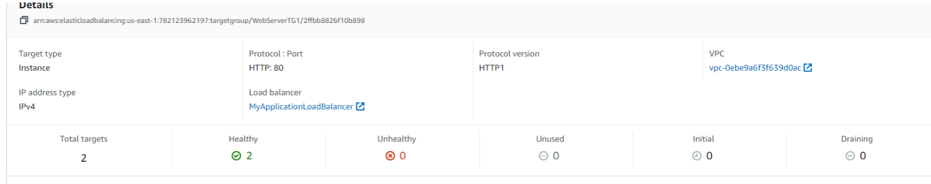
Figure 38: Both instances are Healthy.

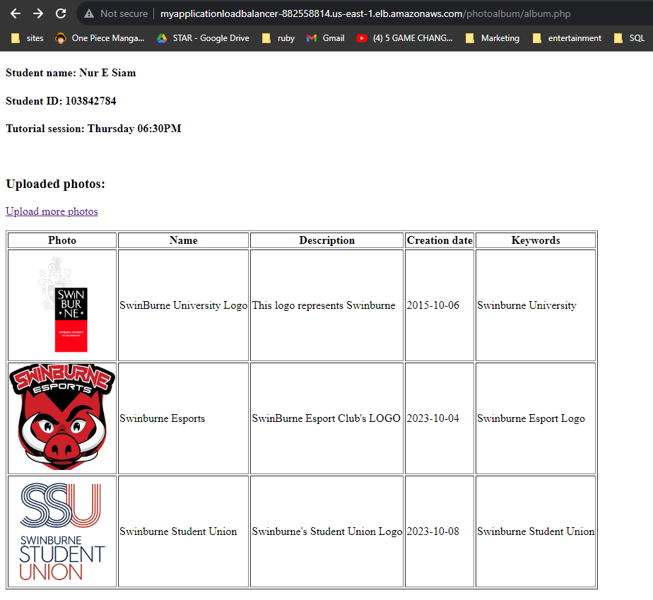
Figure 39: The LB DNS is still accessible after the termination and initialization of new Web instance.
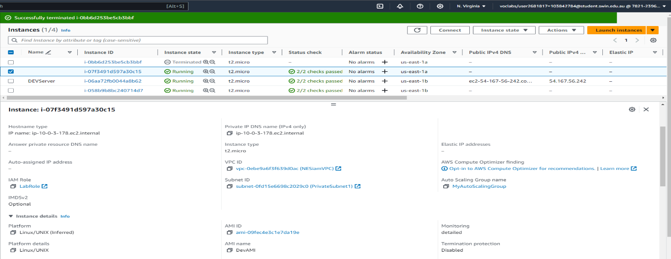
Figure 40: The new Web instance have the same Security and IAM role.

References

Link to the ELB album.php: http://myapplicationloadbalancer-882558814.us-east-1.elb.amazonaws.com/photoalbum/album.php
Link to the ELB photouploader.php: http://myapplicationloadbalancer-882558814.us-east-1.elb.amazonaws.com/photoalbum/photouploader.php
Link to the DevServer: http://ec2-54-167-56-242.compute-1.amazonaws.com/

